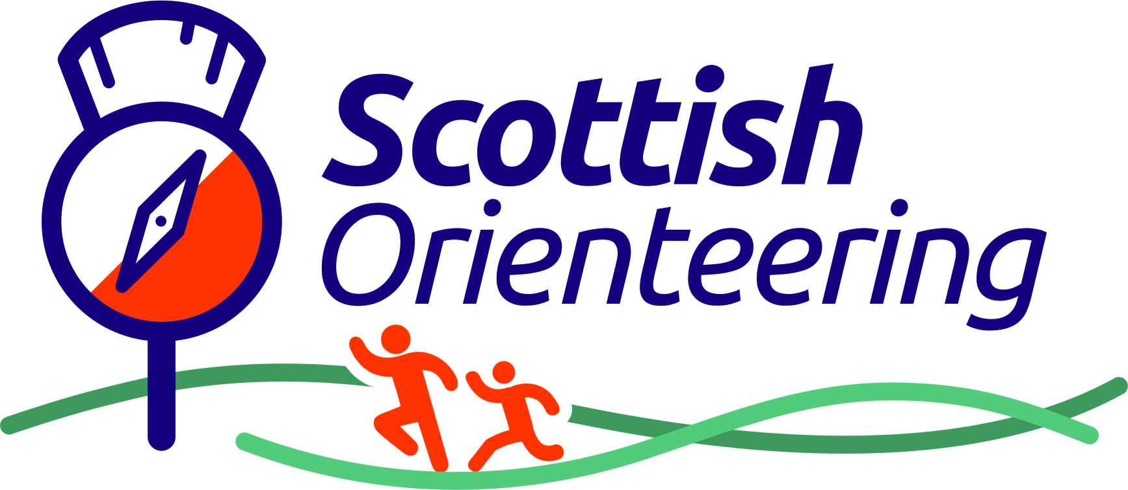
APPLICATION FOR SCOTTISH MEMBERSHIP for 2020
This form can be used instead of applying online at www.scottish-orienteering.org for membership of the Scottish Orienteering Association and your local orienteering club. Membership is valid until 31st December 2020, you will be sent notification of renewal date from the SOA Office.
For additional family members at the same address, add details overleaf.
Fields marked with * are required.
FIRST NAME* |  |  |  |  | FAMILY NAME*
YEAR OF BIRTH* |  |  |  |  | CLUB*
HOME ADDRESS*
E-MAIL (required)*
PHONE |  |  |  |  | MOBILE*
Please provide details of who to contact in case of emergency:
Name* |  |  |  | Contact number*
(Optional) If you have any medical issues that could affect you when orienteering, please give details; also any additional needs that we can support you with:
Do you consider yourself to have a disability? |  |  |  |  |  |  |  |  | Yes / No
Have you been a member of Scottish or British Orienteering within the last 5 years?* |  |  |  |  |  |  |  |  | Yes / No
I confirm I have read the terms and conditions of membership, including how my data will be stored and used.

Signature: Date:

PAYMENT: PLEASE PAY BY CASH or CHEQUE PAYABLE TO NATIONAL ORIENTEERING CENTRE
TOTAL DUE:
Gift Aid: If you are a UK tax payer, this can make a huge difference to us as an organisation. We can claim back 20% tax on your membership fee, as the SOA is a registered charity.
Yes, I want to Gift Aid all donations I have made to the Scottish Orienteering Association in the past 4 years and all donations I make in the future.
I am a UK taxpayer and understand that if I pay less Income Tax and/or Capital Gains Tax than the amount of Gift Aid claimed on all my donations in that tax year it is my responsibility to pay any difference.
Please notify the SOA if you:
- Want to cancel this declaration
- Change your name or home address
- No longer pay sufficient tax on your income and/or capital gains
If you pay Income Tax at the higher or additional rate and want to receive the additional tax relief due to you, you must include all your Gift Aid donations on your Self-Assessment tax return or ask HM Revenue and Customs to adjust your tax code.
ADDITIONAL FAMILY MEMBERS  if they use a different family name, please state it below |  |  |  |  | FAMILY NAME  if same for all
NAME |  |  |  |  | YEAR OF BIRTH
NAME |  |  |  |  | YEAR OF BIRTH
NAME |  |  |  |  | YEAR OF BIRTH

PLEASE SUPPLY EMERGENCY CONTACTS FOR THESE ADDITIONAL FAMILY MEMBERS IF NOT YOURSELF;
ALSO IF ANY OF THESE ADDITIONAL FAMILY MEMBERS HAVE HEALTH OR OTHER CONDITIONS THAT CLUB OR EVENT OFFICIALS SHOULD BE AWARE OF, PLEASE GIVE DETAILS:

PAYMENT DUE: (see bottom of page to view current rates)
SOA Fees £2 per Junior & £10 per Senior  Club fees are £ per Junior & £ per Senior | Rate  £ | How many? | Sub-total  £
Junior (Aged 20 or under by 31st October 2020)
Senior (Over the age of 21)
TOTAL – transfer to other side
We want to keep in touch but need your permission! If you would like to receive email communications from us, please select from the following options:
☐ information about the Scottish Orienteering Association (SOA);
☐ Regular newsletters include details of upcoming events and coaching courses.
You may change your preferences at any time or request that we stop sending you email communications by contacting us at info@scottish-orienteering.org. There is also an ‘unsubscribe’ button at the bottom of every email communication we send.
The Scottish Orienteering Association shares personal details inclusive of your full name, year of birth (to establish your age category) and your registered club affiliation with event officials. Event officials are classified as the club organising the event with which the SOA has non-disclosure agreements in place with these third parties. We share your membership details to our online entry systems, namely Fabian4 and SiEntries, as well as our sister company, Scottish Orienteering 6-Day Event Company Limited, to allow your discounted member entry rates to apply. We do not sell your data to any third party. If you wish to opt out of sharing your personal data (as detailed above) for the purpose of entering orienteering events, please email us at info@scottish-orienteering.org For further details on how your data is used and stored: https://www.scottish-orienteering.org/soa/page/soa-privacy-notice

